# How to use razor engine for email template in ASP.NET Core

## Introduction

This sample demonstrates how to use razor engine for email template in ASP.NET Core.

## Sample prerequisites

* Visual Studio 2017 or above. [[Visual Studio Home Page](https://www.visualstudio.com/)]
* Visual Studio enabled ASP.NET Core develop component.

## Building the sample

Use Visual Studio to open the sample solution **CSEmailRazorTemplateNetCore**, then press F6 Key to build the sample project.

## Running the sample

* Use Visual Studio to open the sample solution **CSEmailRazorTemplateNetCore**, then press F5 Key or select Debugging from the menu.
* When the project is running, you will see below page in browser.

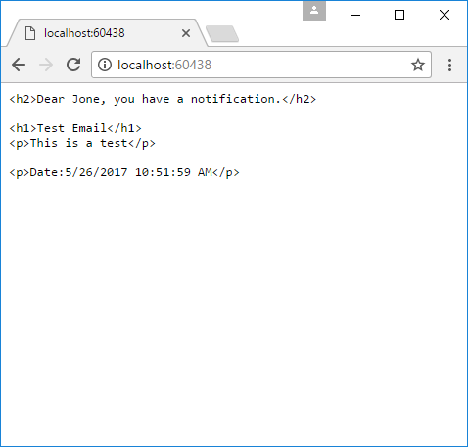

## Using the code

HomeController.cs

public class HomeController : Controller

{

public string Index()

{

string templatePath = $@"{Directory.GetCurrentDirectory()}\EmailTemplates";

IRazorLightEngine engine = EngineFactory.CreatePhysical(templatePath);

var model = new Notification

{

Name = "Jone",

Title = "Test Email",

Content = "This is a test"

};

string result = engine.Parse("template.cshtml", model);

return result;

}

}

Template.cshtml

<h2>Dear @Model.Name, you have a notification.</h2>

<h1>@Model.Title</h1>

<p>@Model.Content</p>

<p>Date:@DateTime.Now</p>

## More information

RazorLight in gitbub

<https://github.com/toddams/RazorLight>